**DTH BASED FAN CONTROL**

**ABSTRACT**

This paper presents the design and implementation of a temperature-based speed-controlled fan system utilizing a DTH (Temperature and Humidity) sensor. The proposed system aims to regulate fan speed according to ambient temperature, ensuring optimal cooling efficiency while minimizing energy consumption. The system comprises three main components: the DTH sensor, microcontroller unit, and fan assembly. The DTH sensor continuously monitors ambient temperature and humidity levels. This data is fed into the microcontroller, which processes the information and determines the appropriate fan speed based on predefined temperature thresholds. Through programmed algorithms, the microcontroller adjusts the fan speed in real-time to maintain a comfortable environment. During high temperatures, the fan operates at higher speeds to enhance cooling effectiveness, while lower speeds are utilized in moderate conditions to conserve energy. The implementation of the temperature-based speed-controlled fan system offers several advantages, including improved energy efficiency, enhanced comfort, and reduced wear and tear on the fan motor. Additionally, the integration of the DTH sensor enables the system to adapt to changing environmental conditions, ensuring consistent performance across varying climates. Experimental results demonstrate the effectiveness of the proposed system in maintaining optimal temperature levels while minimizing energy consumption. Overall, the temperature-based speed-controlled fan with a DTH sensor presents a promising solution for achieving efficient and intelligent climate control in residential and commercial settings. This abstract outlines the purpose, components, functionality, advantages, and experimental validation of the proposed system, providing a concise overview of its significance and potential applications.

**Components:**

* [Arduino UNO](https://robu.in/?category=&s=arduino+uno&search_posttype=product)
* USB A to B
* Breadboard
* [DHT11 sensor](https://robu.in/?category=&s=dht11&search_posttype=product)
* [DC Fan](https://robu.in/?category=&s=5v+fan&search_posttype=product)
* [2n2222 transistor](https://robu.in/product/2n2222-npn-transistor-pack-of-20/)
* [16x2 LCD](https://robu.in/?category=&s=16x2&search_posttype=product)
* [Connecting wires](https://robu.in/product/10-cm-40-pin-dupont-male-male-male-female-female-female-cable-combo/)

Working Images:

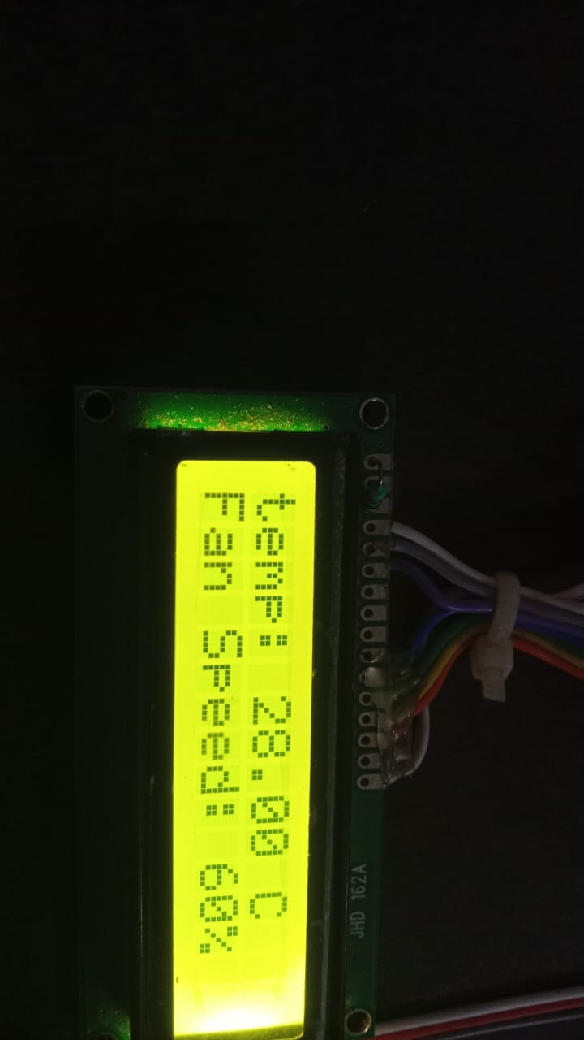

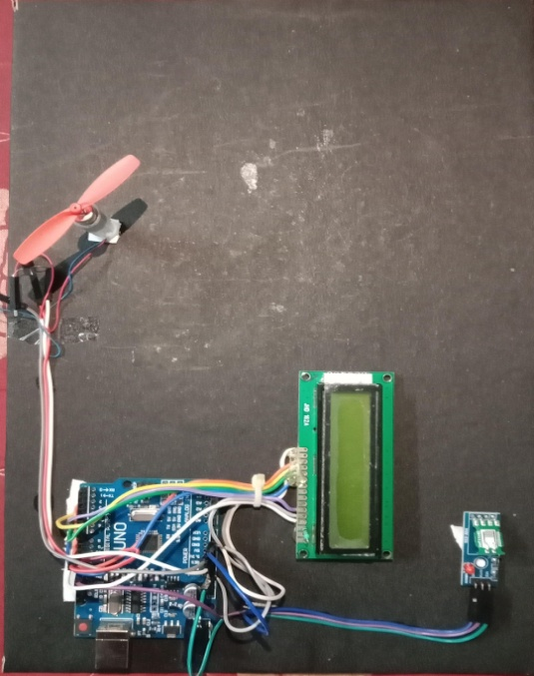

Program Used: